READINGS FOR THIS WEEK

Nov 20 Sun: 2 Sam 5:1-3/Ps 122/Col 1:12-20/Lk 23:35-43
Nov 21 Mon: Rev 14:1-3,4b-5/Ps 24/Lk 21:1-4
Nov 22 Tue: Rev 14:14-19/Ps 96/Lk 21:5-11
Nov 23 Wed: Rev 15:1-4/Ps 98/Lk 21:12-19
Nov 24 Thur: Rev 18:1-2, 21-23; 19:1-3,9a/Ps 100/Lk 21:20-28
Nov 25 Fri: Rev 20:1-4, 11-21:2/Ps 84/Lk 21:29-33
Nov 26 Sat: Rev 22:1-7/Ps 95/Lk 21:34-36
Nov 27 Sun : Is 2:1-5/Ps 122/Rom 13:11-14/Mt. 24:37-44

BIRTHDAYS

November 22 Mary Cooley-Hechmer

ANNIVERSARIES
November 20 Paul & Katie Hogan

PLEASE PRAY FOR

Liam Morstorf John Hawks
Mike Cruise Dave Pettinger
Wayne Moore Catie Hunter
Phyllis Brokaw Doug Hardisty
Ellen Gruba

LITURGICAL ASSIGNMENTS

NOVEMBER 27 - 10:30 A.M.
SERVERS: Wyatt/Ciara Konecne
LECTOR: Jamie Hogan
E.M. BREAD: Mark Reichenauer
SACRISTAN: Will Foley
USHERS: Barb Fuller & Danny S.
GIFT BEARERS: Arnold & Stacy Maynes
MUSICIAN: Carol Hardisty
CANTOR: Carol Miller

OFFICE HOURS

Tuesday - 8:30a.m. – 4:00p.m.
Thursday - 8:30a.m. – 4:00p.m.

Office will be Closed on Nov. 24.
Have a blessed holiday.

2022 ADA

Thank you to everyone who has already sent in their Diocesan Appeal Donations. We have $5,000.00 left to reach our goal.

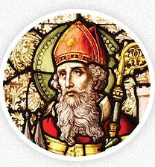
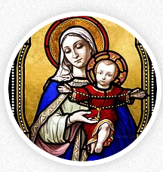
ST. PATRICK
CATHOLIC CHURCHES
Fr. Emmanuel Bassey

THE SOLEMNITY OF OUR LORD JESUS CHRIST,
KING OF THE UNIVERSE
NOVEMBER 20, 2022

ST. PATRICK, CORNING
504 Grove Ave. • Corning, IA 50841
Office Phone: . . . . . . . . . . . . . . . . .641-322-3363
E-mail: . . . . . . . . . . . . . pat_corning@yahoo.com
Website: . . . . . . . . . www.stpatrickcorning.com
Fr. Emmanuel Bassey . . . . . . . . . . 818-301-8456
Hall Rental: . . . . . . . Rosie Bissell 712-621-0942
RE :. . . . . . . . . . . . . .Tamara Haley 641-418-0122
Office Manager: . . . Deb Moore 641-344-9558
Prayer Chain: . . . . . . . . . . . . . . . . . . . . . . . . . . . . . . . . . . . . . . . . Marcella Gearheart 641-322-3885

ST. PATRICK, LENOX
600 W. Michigan • Lenox, IA 50851
Office Phone: . . . . . . . . . . . . . . . 641-333-2565
Email: . . . . . . . . . . . . . . . . stpatl@lenoxia.com
Website: . . . . . . . . . . www.stpatricklenox.com
Fr. Emmanuel Bassey. . . . . . . . . 818-301-8456
Office Manager/Religious Education: . . . . . . . . . . . . . . . . . . . . . . . . . . . . . . . . . . . . Kathy Ecklin
Ministry of Caring: . . . . . . . . . . . . . . . . . . . . . . . . . . . . . . . . . . . . . .Kathy Ecklin at 641-333-2565
. . . . . . . . . . Marilyn Rychnovsky 641-335-2268

STEWARDSHIP REPORT
November 13, 2022 $ 782.00
ADA amount remaining $ 5,000.00
Total Ignite Pledges Made $52,020.00

Interested in Making Your Church Support Tithe by Auto Debit?
Please see Deb for more information.

MASS SCHEDULE
L, Sun., Nov 20 8:30 a.m., Mike & Jerolyn Weese
C, Sun., Nov 20 10:30 a.m., Helen Hogan
L, Sun., Nov 20 5:30 p.m., Fr. Tan Van Tran

C, Tue., Nov 22 Noon, Eleanor Cantieri
St. Cecilia, Virgin & Martyr

L, Wed., Nov 23 8:30 a.m., Delbert Heim
St. Clement, Pope & Martyr; St. Columban, Abbot; USA – Blessed Miguel Agustin Pro, Priest & Martyr

L, Thur., Nov 24 7:00 a.m. People of the Parish
C, Thur., Nov 24 9:00 a.m., John Reichenauer
Blessing of Thanksgiving Items
St. Andrew Dung-Lac, Priest & Companions, Martyrs

L, Fri., Nov 25 8:30 a.m., Leo & Elda Ryan
St. Catherine of Alexandria, Virgin & Martyr

C, Sat., Nov 26 5:30 p.m., Alan Luther

L, Sun., Nov 27 8:30 a.m., David Heim
C, Sun., Nov 27 10:30 a.m., Debbie Hogan
L, Sun., Nov 27 5:30 p.m., Margaret Jones
KINGDOM OF THE SON
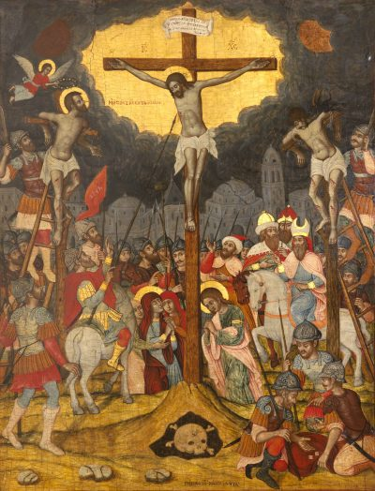

Week by week, the Liturgy has been preparing us for the revelation to be made on this, the last Sunday of the Church year.

Jesus, we have been shown, is truly the Chosen One, the Messiah of God, the King of the Jews. Ironically, in today’s Gospel we hear these names on the lips of those who don’t believe in Him—Israel’s rulers, the soldiers, a criminal dying alongside Him.

They can only see the scandal of a bloodied figure nailed to a cross. They scorn Him in words and gestures foretold in Israel’s Scriptures (see Psalm 22:7–9; 69:21–22; Wisdom 2:18–20). If He is truly King, God will rescue Him, they taunt. But He did not come to save Himself, but to save them—and us.
The good thief shows us how we are to accept the salvation He offers us. He confesses his sins and acknowledges he deserves to die for them. And he calls on the name of Jesus, seeking His mercy and forgiveness.

By his faith he is saved. Jesus “remembers” him—as God has always remembered His people, visiting them with His saving deeds, numbering them among His chosen heirs (see Psalm 106:4–5).

By the blood of His cross, Jesus reveals His Kingship—not in saving His own life, but in offering it as a ransom for ours. He transfers us to “the kingdom of His beloved Son,” as today’s Epistle tells us.

His kingdom is the Church, the new Jerusalem and House of David that we sing of in today’s Psalm.

By their covenant with David in today’s First Reading, Israel’s tribes are made one “bone and flesh” with their king. By the New Covenant made in His blood, Christ becomes one flesh with the people of His kingdom—the head of His body, the Church (see Ephesians 5:23–32).

We celebrate and renew this covenant in every Eucharist, giving thanks for our redemption, hoping for the day when we too will be with Him in Paradise.

CATHOLIC CAMPAIGN FOR HUMAN DEVELOPMENT

This Sunday is the special collection to support the Catholic Campaign for Human Development. Envelopes for this campaign are attached to this week’s bulletin. For more than 50 years, the Catholic Campaign for Human Development (CCHD) has supported organizations that combat poverty and improve the lives of people in communities across the United States. To learn more about the collection and the way CCHD upholds the moral and social teachings of the Catholic Church, visit www.usccb.org/cchd/collection.

THANKSGIVING DAY CELEBRATION

There will be Thanksgiving Day Mass on Thursday, November 24, 2022 at 9:00 a.m. As we did last year, everyone is invited to bring at least a symbol of their thanksgiving meal to be blessed during the Mass.

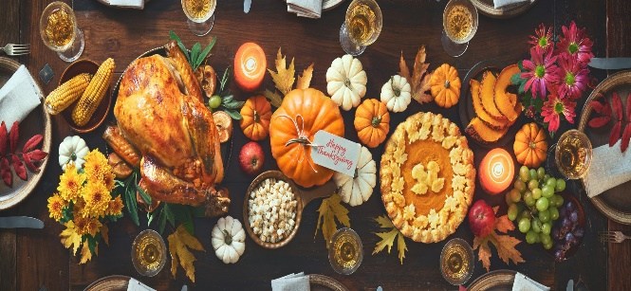

IGNITE! CAMPAIGN: COMMITMENT WEEKEND

We say thank you to everyone who made pledges on the commitment Sunday. We are so blessed to have received such a positive response. We encourage those yet to make any pledge to prayerfully consider doing so.
NEW LECTOR WORKBOOK

The new Lector Workbook for 2023 Liturgical Year is out. All Lectors should pick up their copies from the Sacristy.

ADVENT

As the season of Advent begins next week, we will pray the Rosary at 10:00 a.m. each Sunday before Mass. There are sign-up sheets behind the church for those who may wish to lead the Rosary for the four weeks of Advent leading to Christmas.

THANK YOU

Thank you to everyone who was able to attend our inaugural fellowship meal, held after Mass last Sunday. Special thanks too to all those who organized and cooked all the delicious meals. May God bless you all. We look forward to having more parishioners around next month.

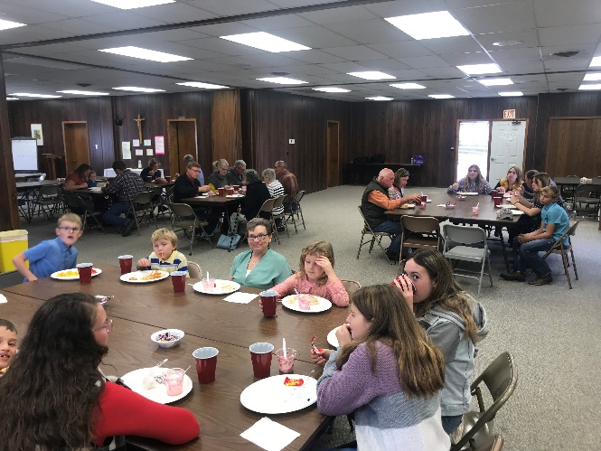

MARK YOUR CALENDAR

Lenox Cookie & Candy Carnival holds on Saturday December 3rd in the Lenox Parish Center. Doors open at 10:00 a.m. until cookies are gone.

